Use the naming rules you have learnt to answer the following questions.

1. 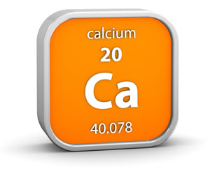Compounds that contain oxygen and one other element are called oxides.

Name these oxides: (3)

* 1. MgO Magnesium oxide
  2. CaO Calcium oxide
  3. Na2O Sodium oxide

1. Some oxides contain more than one oxygen atom. Name these oxides: (3)
   1. CO2 Carbon dioxide
   2. SO2 Sulfur dioxide
   3. SO3 Sulfur trioxide
2. 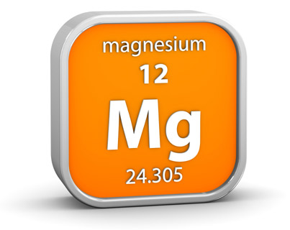Compounds that contain sulfur and one other element are called sulfides.

Name these sulfides: (3)

* 1. FeS Iron sulfide
  2. ZnS Zinc sulfide
  3. H2S Hydrogen sulfide

1. Compounds that contain chlorine and one other element are called chlorides.

Name these chlorides: (3)

* 1. KCl Potassium chloride
  2. NaCl Sodium chloride
  3. HCl Hydrogen chloride

1. 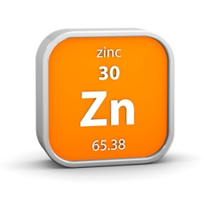Compounds that contain oxygen, sulfur and one other element are called sulfates.

Name these sulfates: (3)

* 1. CuSO4 Copper sulfate
  2. ZnSO4 Zinc sulfate
  3. Na2SO4 Sodium sulfate

1. Compounds that contain oxygen, carbon and one other element are called carbonates.

Name these carbonates: (3)

* 1. CuCO3 Copper carbonate
  2. Na2CO3 Sodium carbonate
  3. MgCO3 Magnesium carbonate

1. 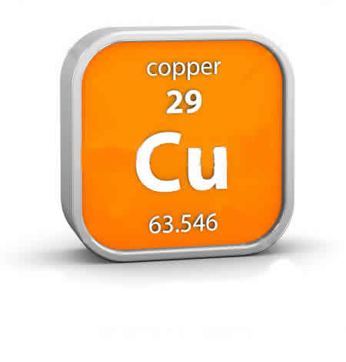Compounds that contain oxygen, nitrogen and one other element are called nitrates.

Name these nitrates: (3)

* 1. NaNO3 Sodium nitrate
  2. KNO3 Potassium nitrate
  3. AgNO3 Silver nitrate

1. Now you've got the hang of it, try naming these compounds: (12)
   1. LiCl Lithium chloride g. CaCO3 Calcium carbonate
   2. MgSO4 Magnesium sulfate h. K2SO4 Potassium sulfate
   3. Li2O Lithium oxide i. RbNO3 Rubidium nitrate
   4. CaS Calcium sulfide j. CaCl2 Calcium chloride
   5. ZnO Zinc oxide k. NiS Nickel sulfide
   6. LiNO3 Lithium nitrate l. K2CO3 Potassium carbonate

*Total marks: 33*

*Extension:*

1. These may look a bit different, but you can use the same rules. Try naming them: (4)
   1. Al2O3 Aluminium oxide c. Al2(SO2)3 Aluminium sulfate
   2. Zn(NO3)2 Zinc nitrate d. Al2(CO3)3 Aluminium carbonate
2. Suggest names for these compounds: (4)
   1. KBr Potassium bromide c. AlPO4 Aluminium phosphate
   2. 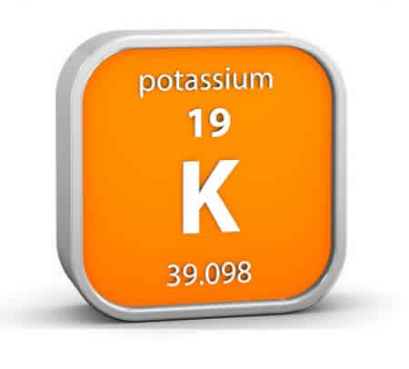BNBoron nitride d. NaHCO3 Sodium hydrogencarbonate
3. Look up the names of these compounds: (2)
   1. KMnO4 Potassium permanganate / potassium manganate(VII)
   2. K2CrO4 Potassium chromate
4. Try to explain the names of the compounds in Q11. (6)
   1. Contains three different elements, one of which is oxygen. (1)

ends in '-ate.' (1)

Manganese becomes manganate. (1)

* 1. Contains three different elements, one of which is oxygen. (1)

ends in '-ate.' (1)

Chromium becomes chromate. (1)

*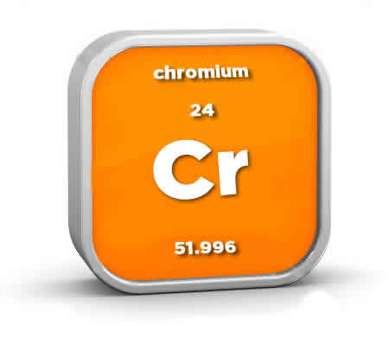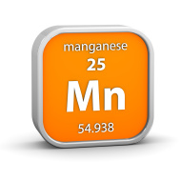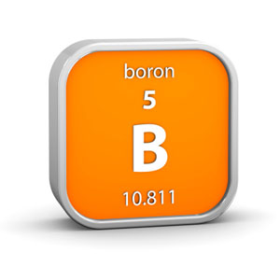Total marks: 49*